**Name**: Samya Sunibir Das

**ID**: 1911563642

**Course and Section**: CSE332.3

**Submission Date**: 18th November 2020

**Lab 3 Table and Discussion**

1. Complete the truth table of the 4-bit multiplier from the manual

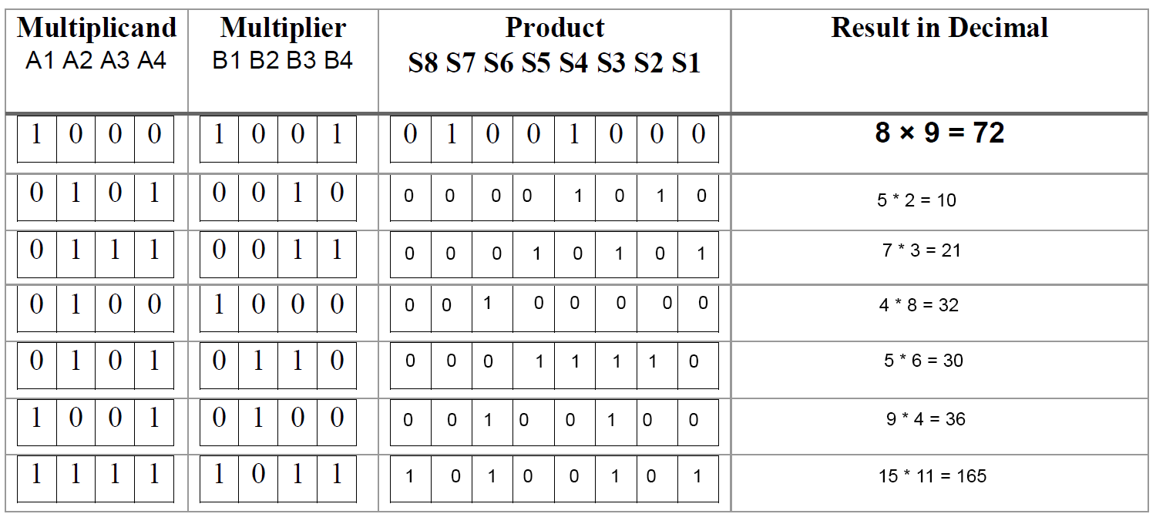

1. Discussion about the topics covered in Lab 3

In the third lab class, we were demonstrated how to design 4-bit multipliers in Logisim. We were also given a detailed explanation on how multiplications are done, for example: multiplying 1000 and 1001 results to 01001000, which is 8 * 9 = 72, in decimal. The main process of binary Multipliers is, they do multiplication of two unsigned binary numbers. Each bit of the multiplier is multiplied against the multiplicand, the product is aligned according to the position of the bit within the multiplier, and the resulting products are then summed to form the final result. The class concluded by instructing us to submit the table and discussion in google classroom and the circuit file simulated in Logisim in git.